26.Design TM using simulator to accept the input string Palindrome bbabb

Aim : To Design TM using simulator to accept the input string Palindrome bbabb

Transition digram:

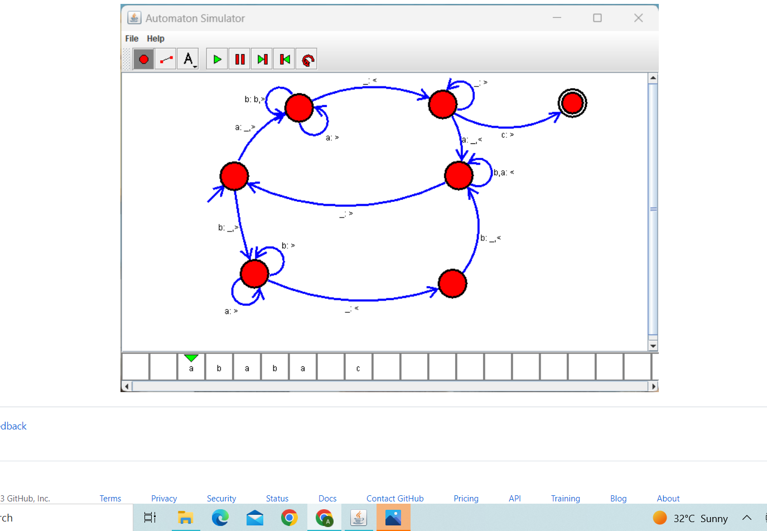

Result: Hence designing TM accepting the palindrome input string bbabb